Housemate Helper

OVO

Completion: 11/16/21

Revision 1: 11/2/21

Sprint 3 Plan

Sprint Goal:

Complete the chores and expenses parts of the application

Task Listing:

* User Story 1: As a housemate, I want to create new chores so that I can assign a housemate to do each chore.
  + Create chore input fields, store inputs (2 hours)
  + Display chores (1 hour)
* User Story 2: As a housemate, I want to be able to add expenses so that my other housemates know how much is being spent.
  + Create expenses input fields and store inputs (2 hours)
  + Display expenses (1 hour)
* User Story 3: As a housemate, I want to be able to split the expenses so that all the housemates can contribute to the costs of living in the house.
  + Split expense by number of people in the group (1 hour)

Team Roles:

* Matthew Atmadja: Product Owner, Developer
* Rishab Aida: Scrum Master, Developer
* Ashvini Bhupatiraju: Developer
* Vinay Prasad: Developer
* Sukhveer Karlcut: Developer
* Rishika Patel: Developer

Initial Tasks Assignments:

* Chores inputs and display
  + Ashvini, Matt
* Expenses input, display, split expenses
  + Rishika, Vinay, Suki, Rishab

Initial Burnup Chart:

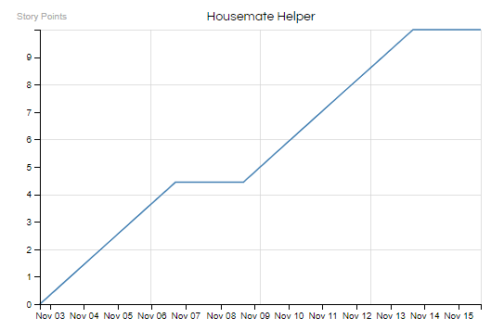

Initial Scrum Board:

| Stories | To Do | In Progress | Done |
| --- | --- | --- | --- |
| User Story 1 | * Create chore input fields * Store inputs (chore, assigned housemate) * Display chores |  |  |
| User Story 2 | * Create expenses input fields * Store inputs (expense, assigned housemate) * Display expenses |  |  |
| User Story 3 | * Calculate split expense * Display split expense |  |  |

Scrum Times:

* Team meets every Tuesday, Thursday, Saturday